Bi-weekly assignment week 3&4 Report

Name: Kriti
Level-3
section-’c’
Module: Fundamentals of Data Science

Count Upper and Lower Case Letters
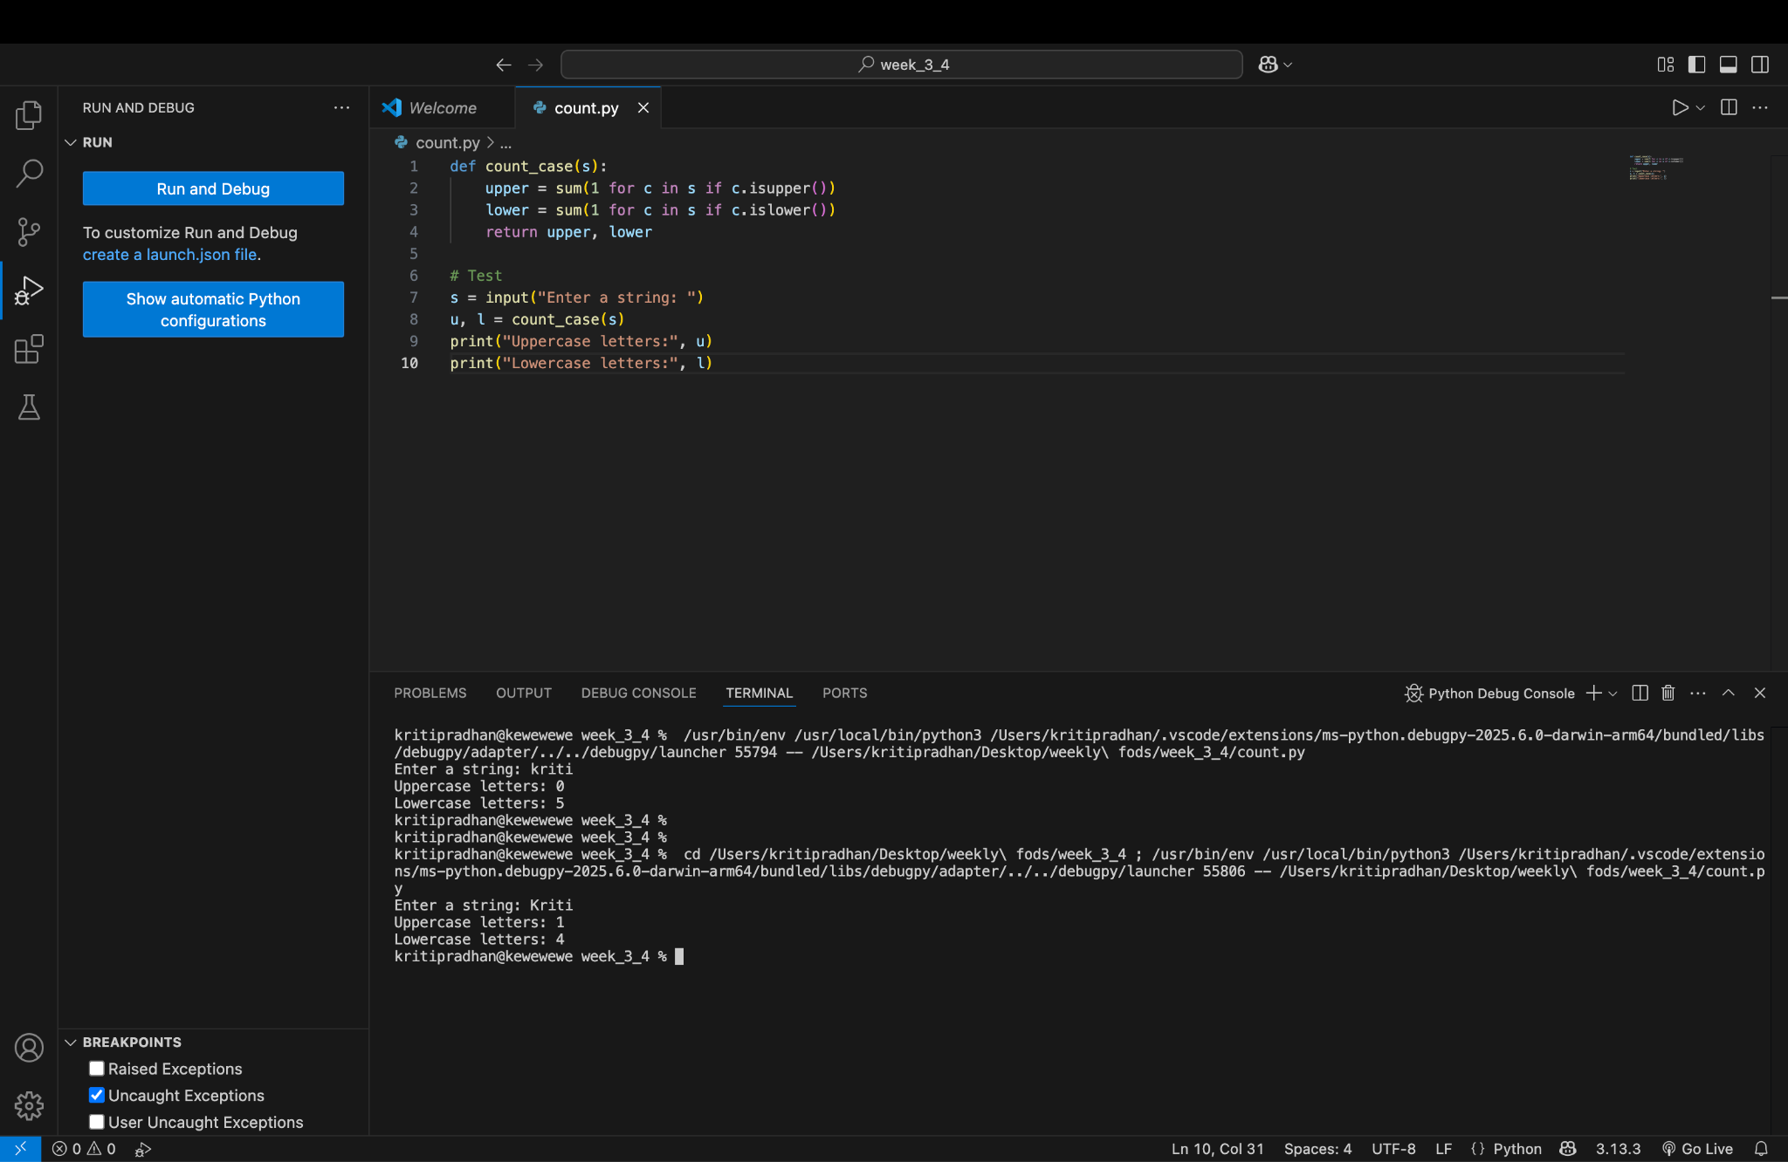

Prime Number Checker
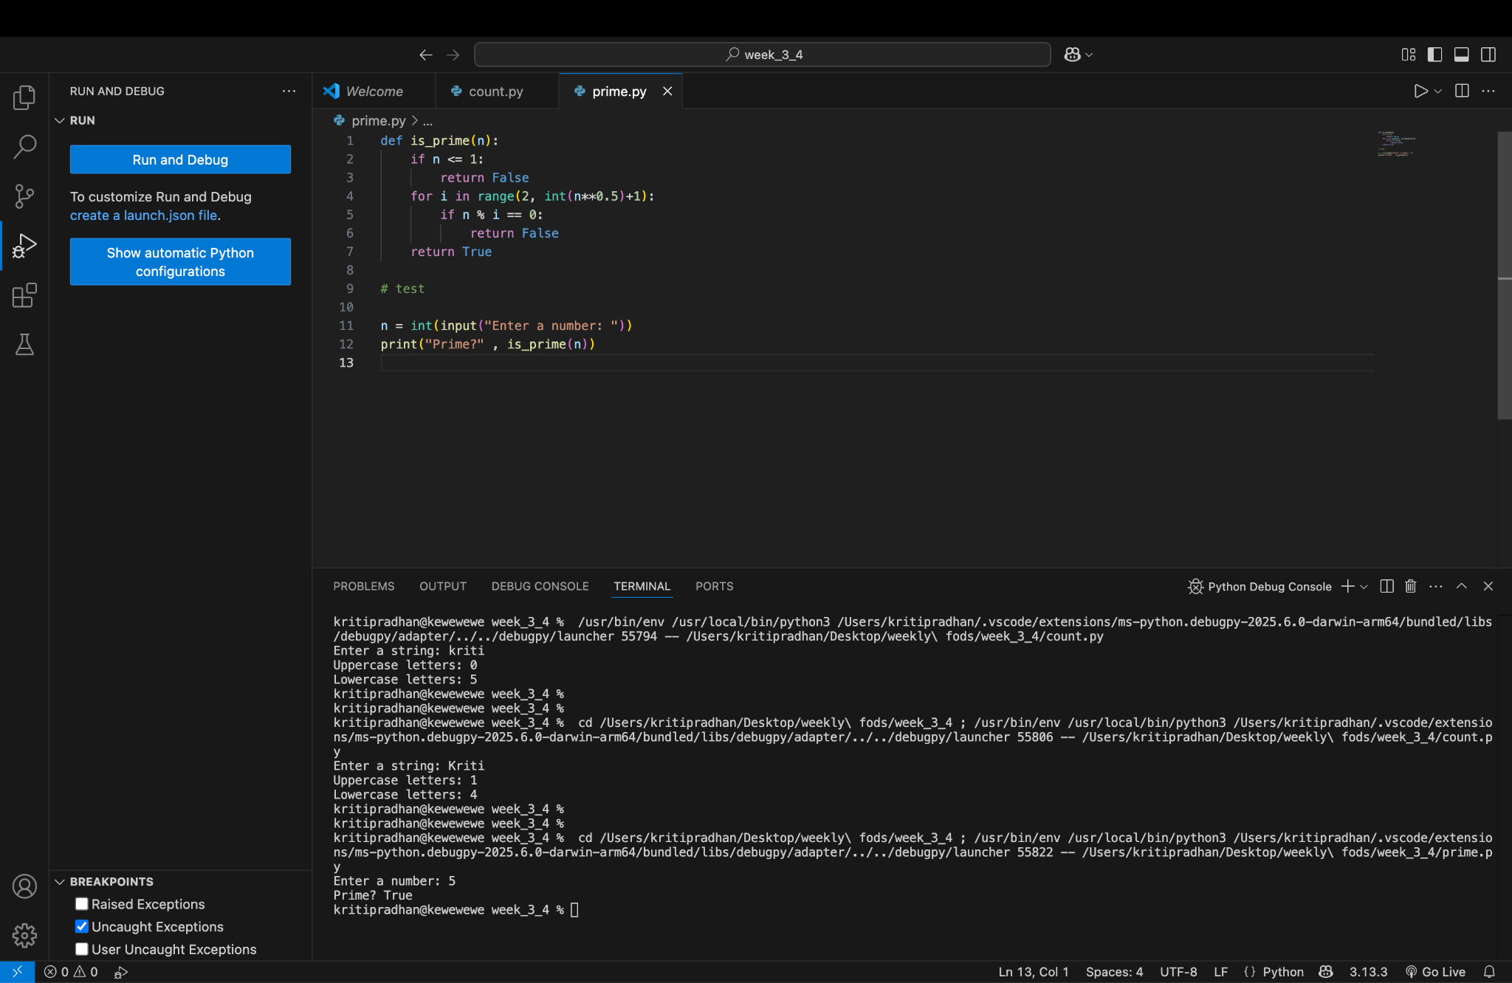
Program 3: Armstrong Number Checker
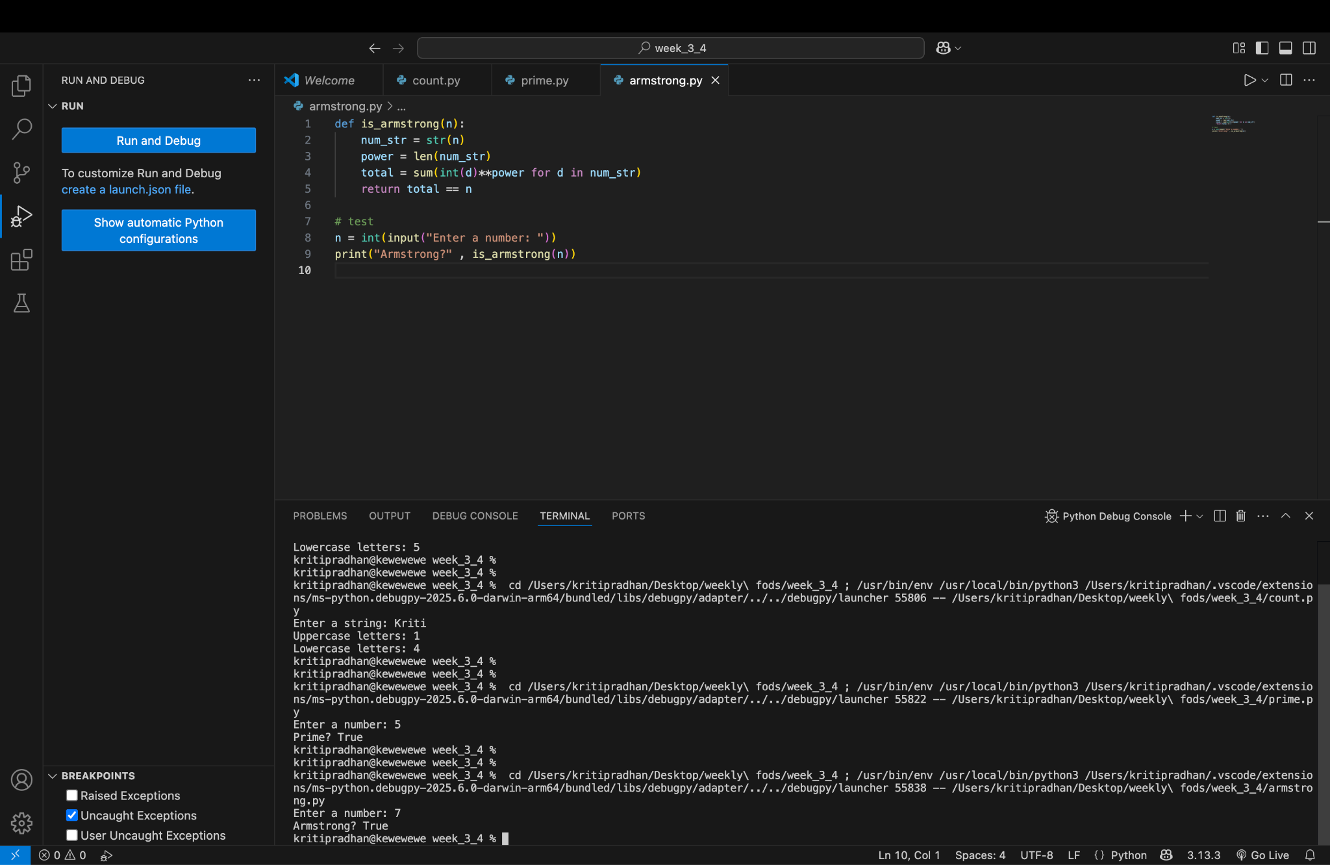

Program 4: Sort List of Names
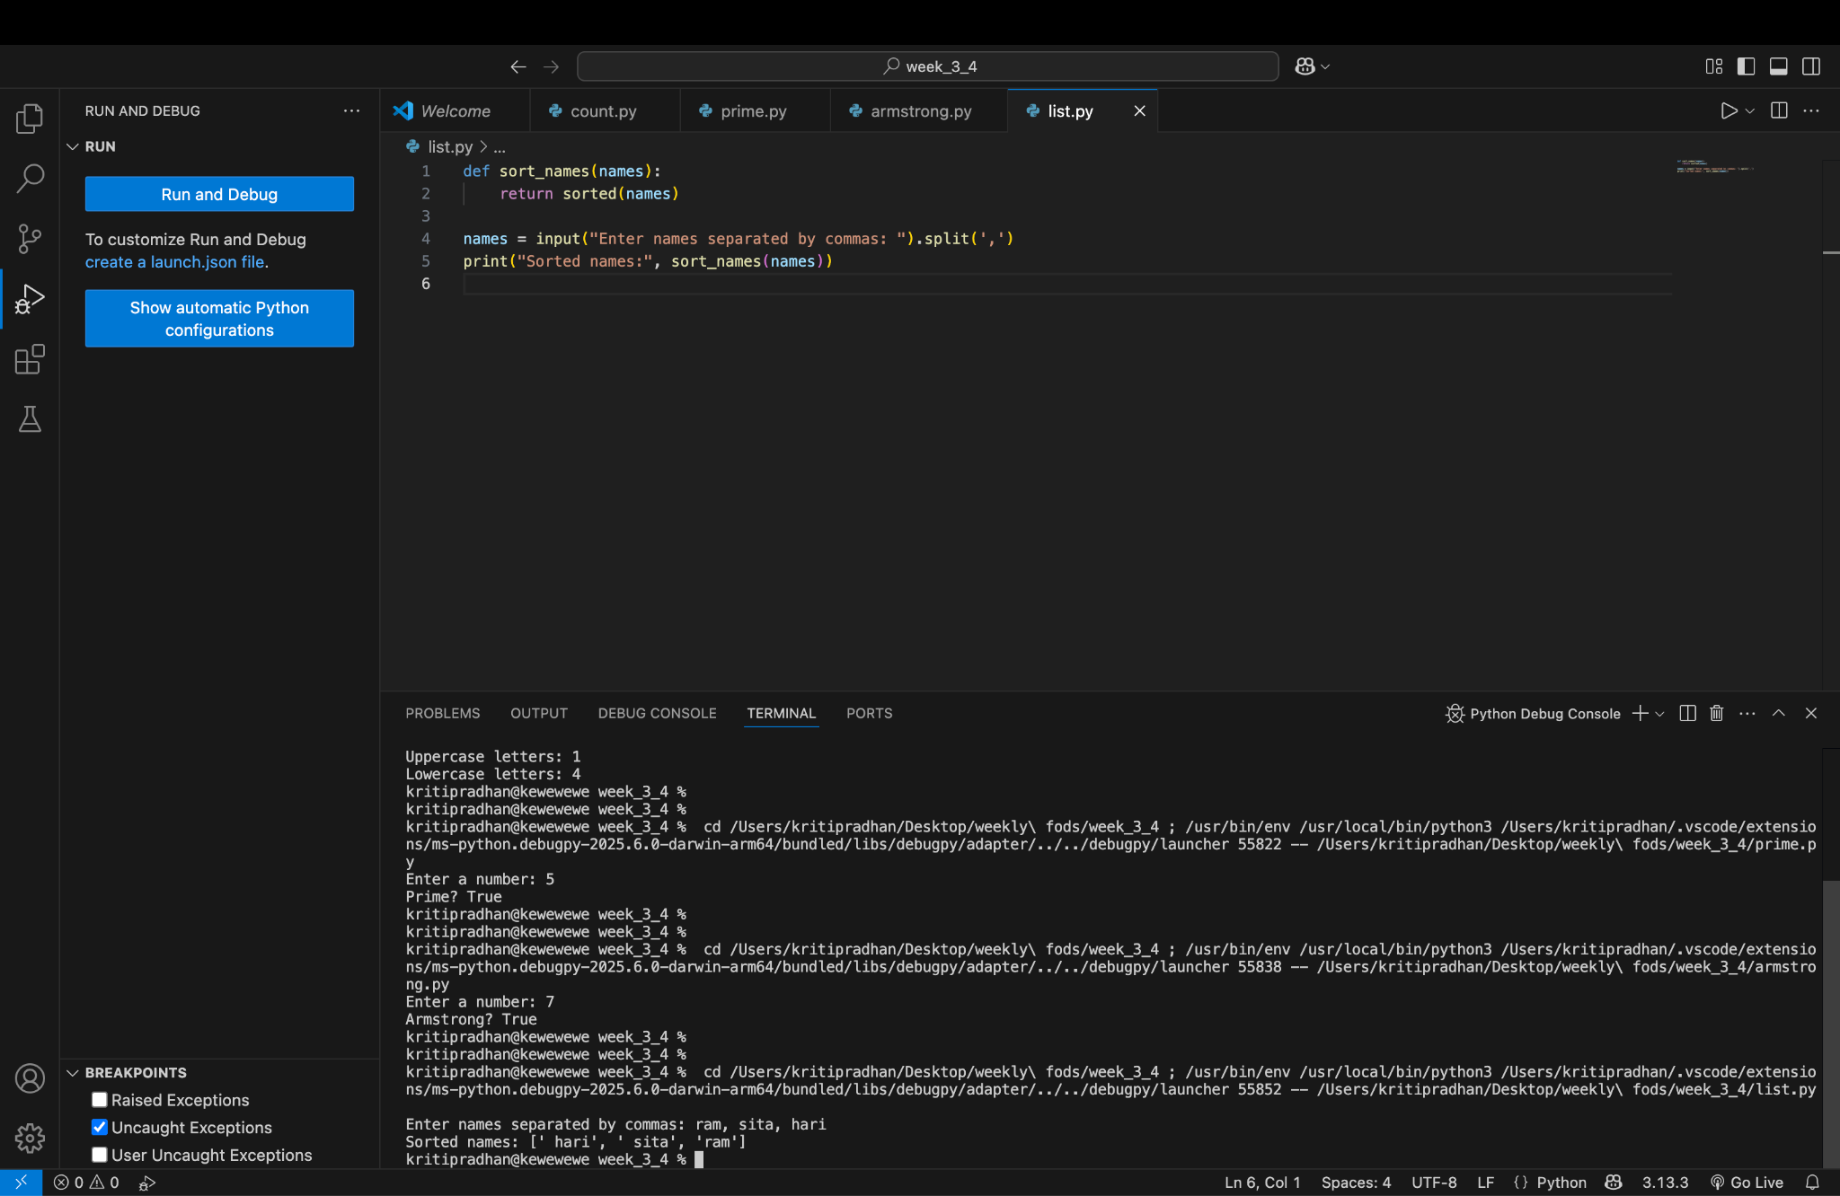
Program 5: Calculator Program
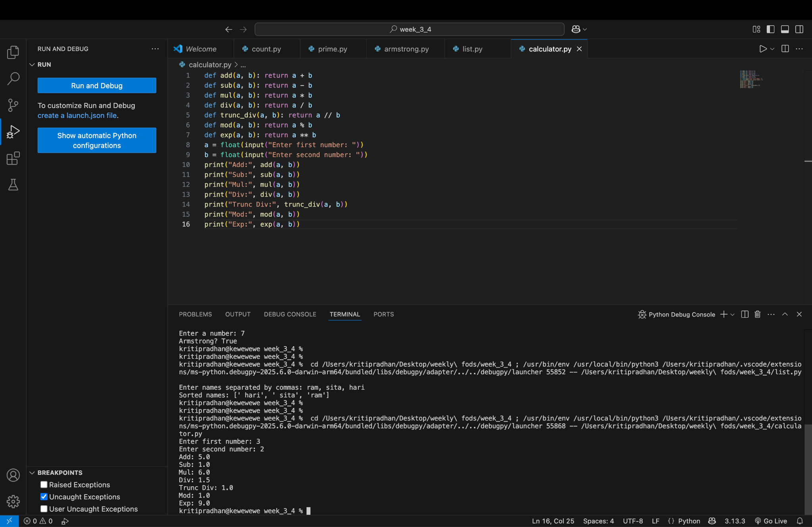

Program 6: Filter List Between 1–100
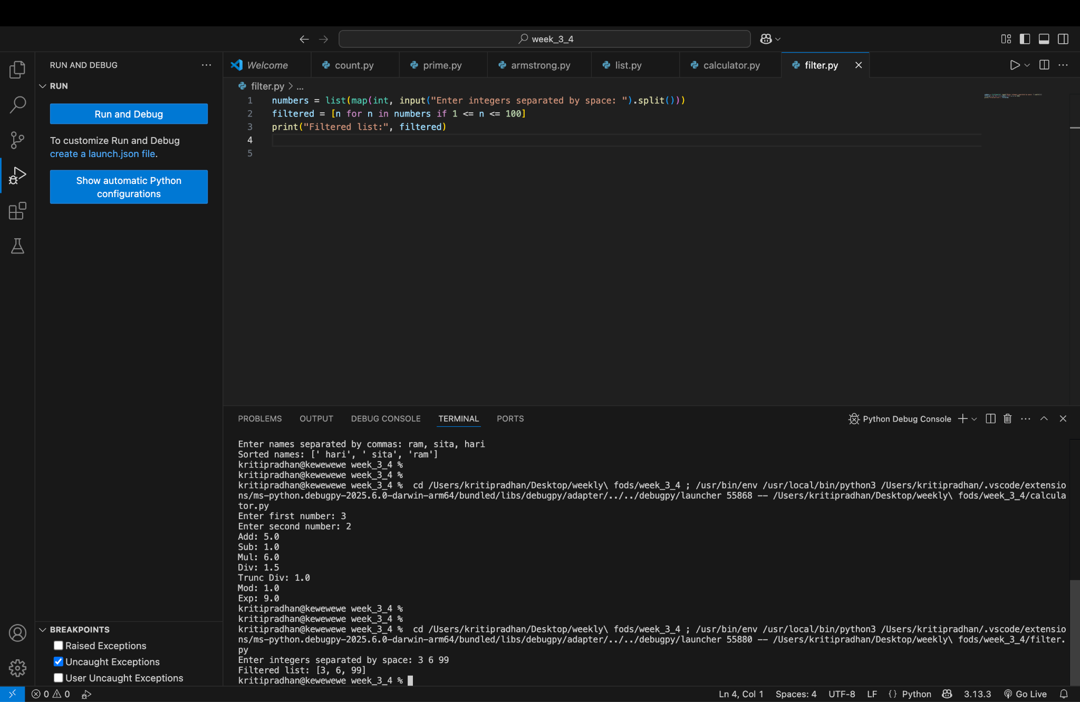
Program 7: Count 'a' in List of Names
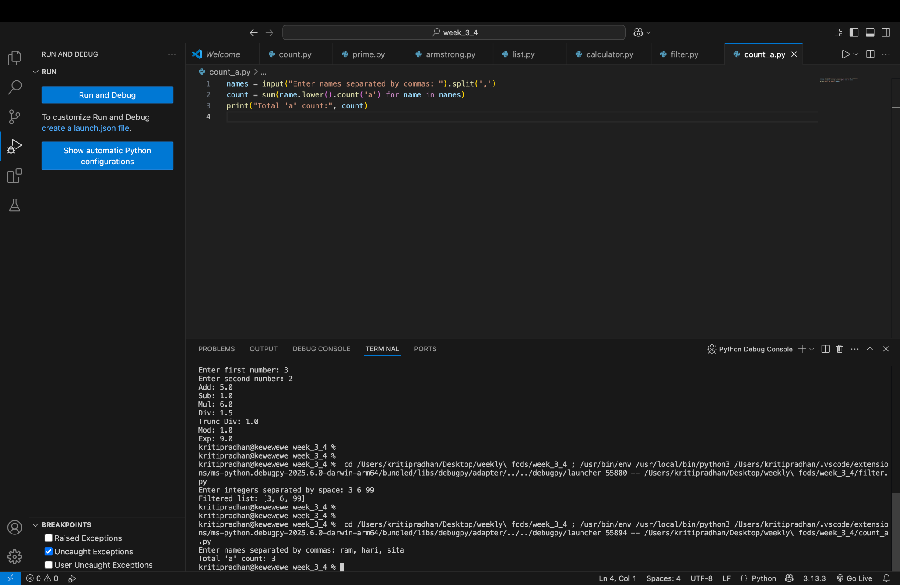

Program 8: Compare Two Lists
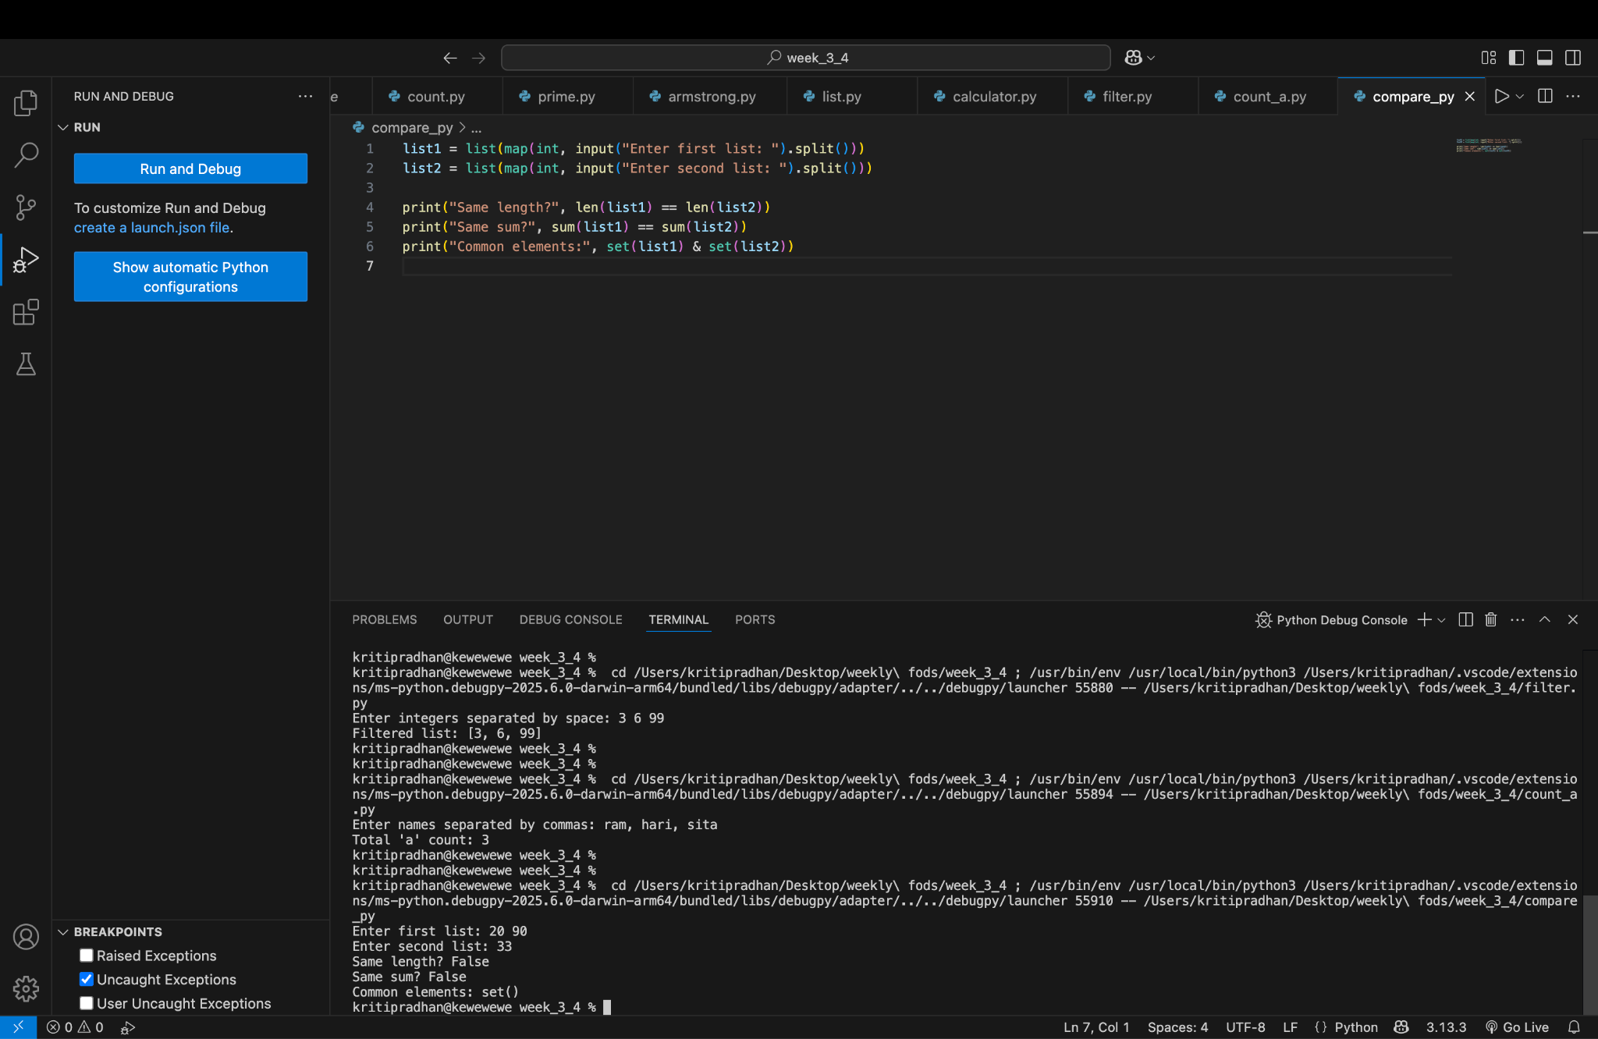

Program 9: Add Daily Temperature
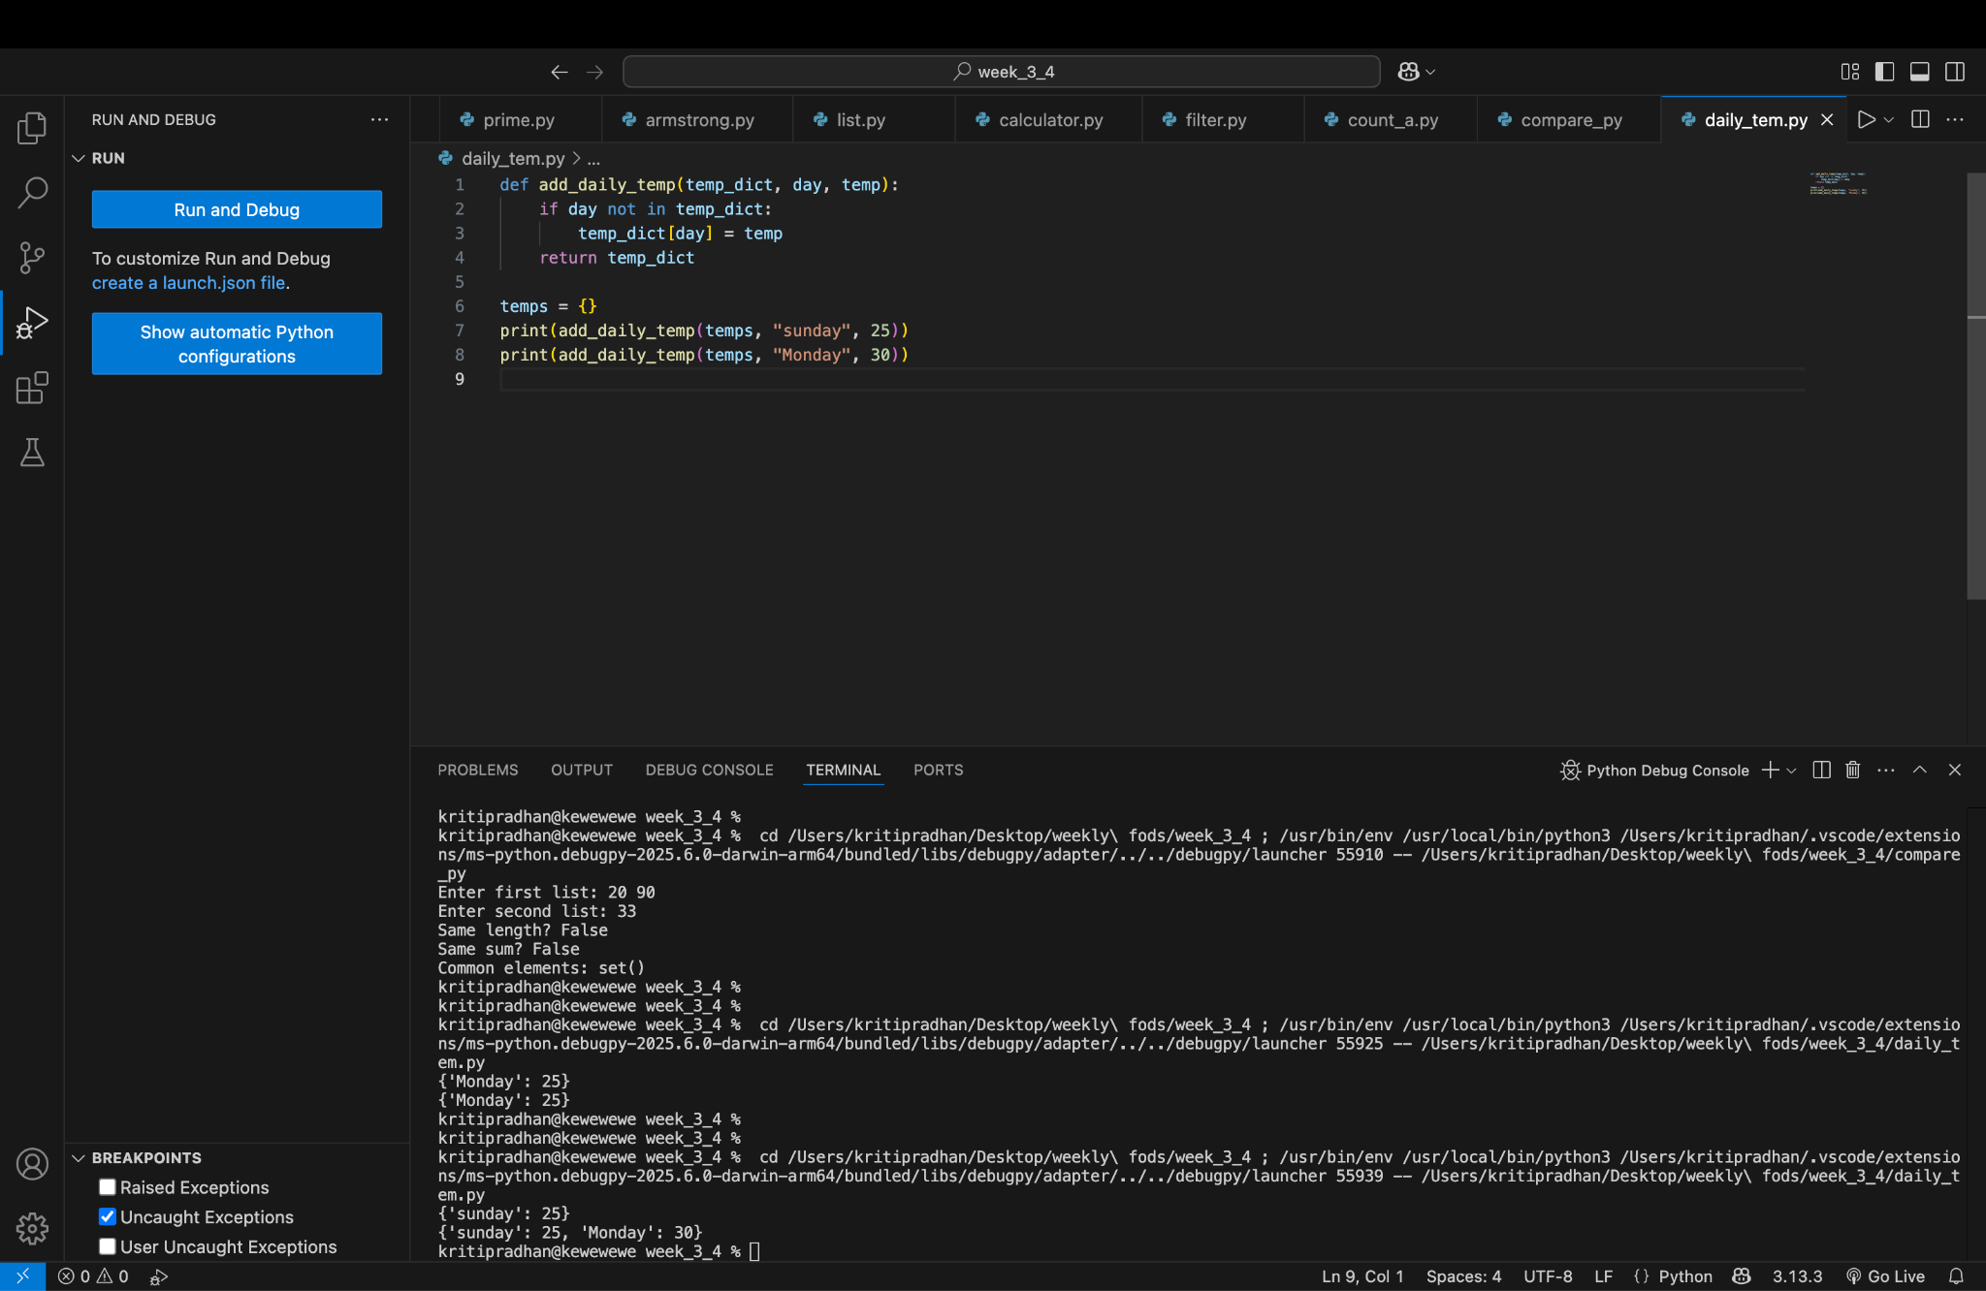

Program 10: Get Daily Temperatures
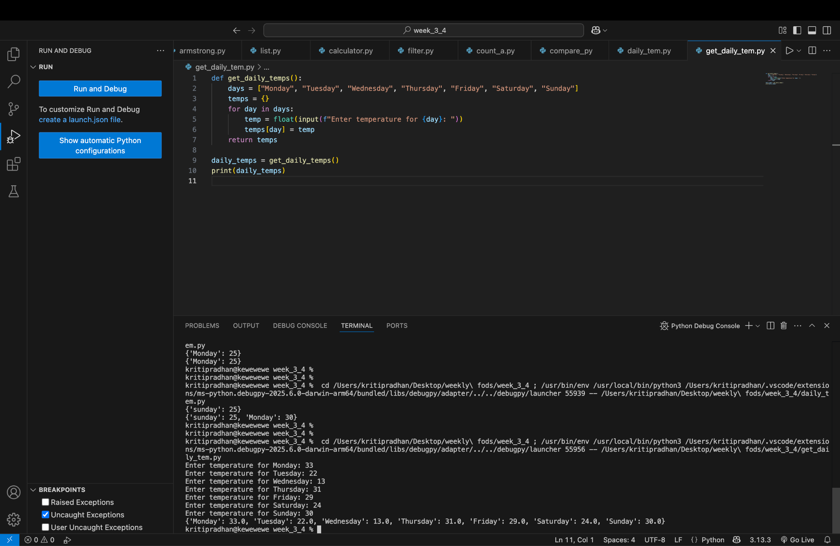
Program 11: Dictionary Operations
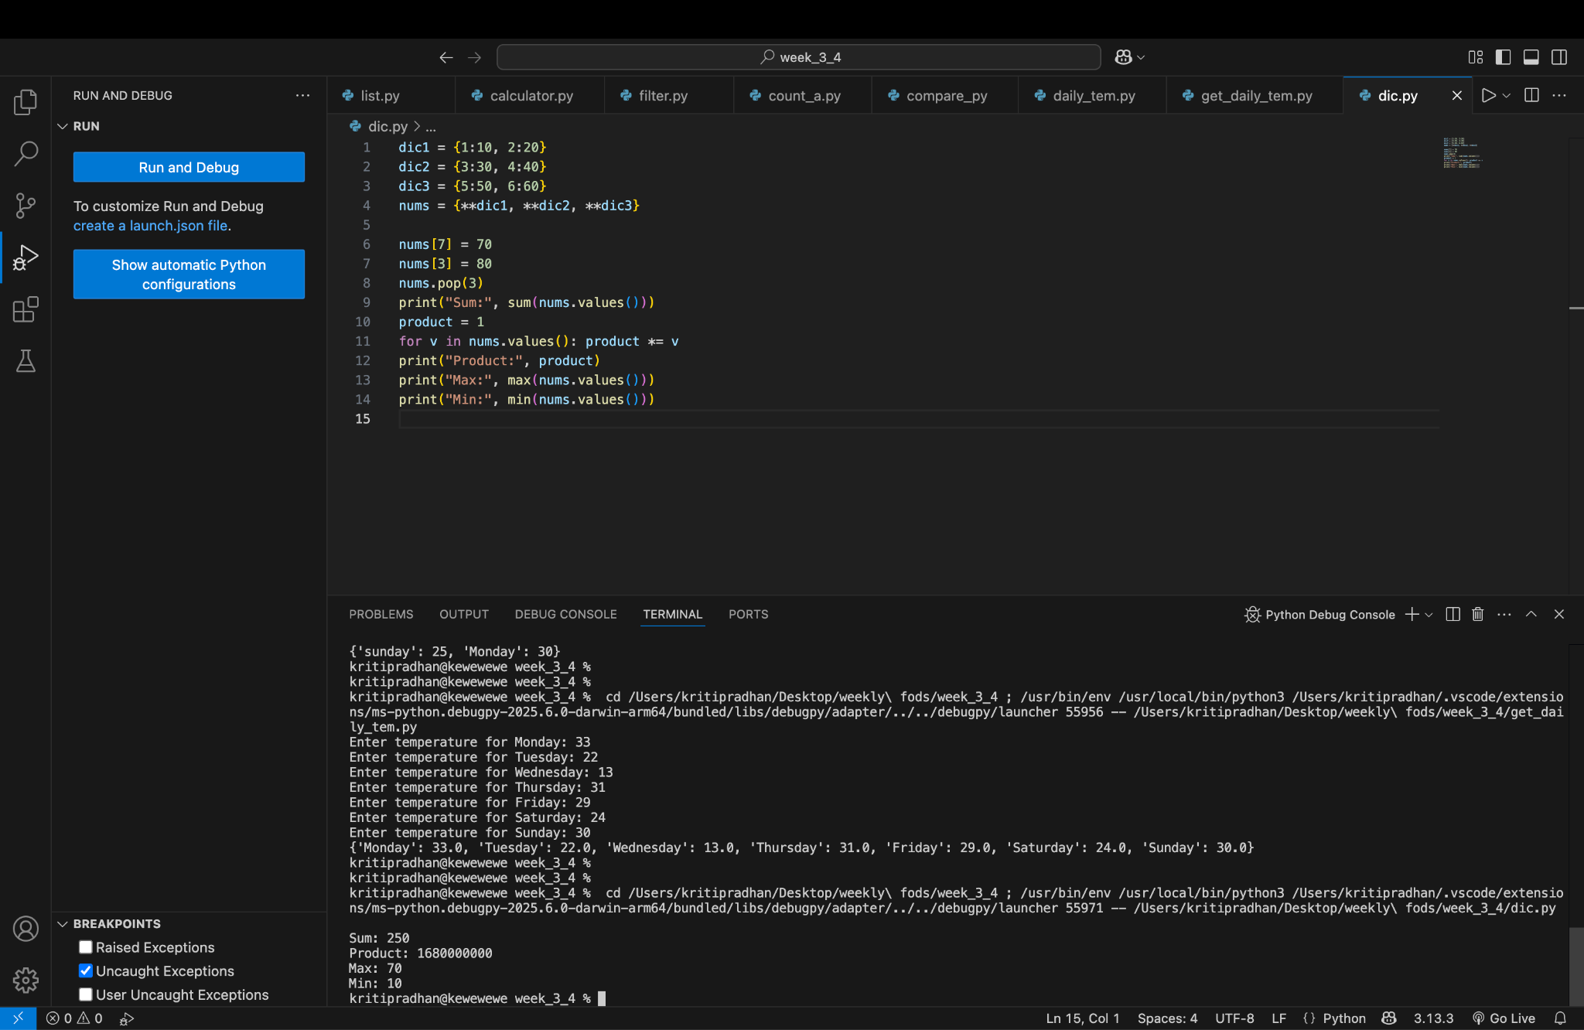

Program 12: Set Operations
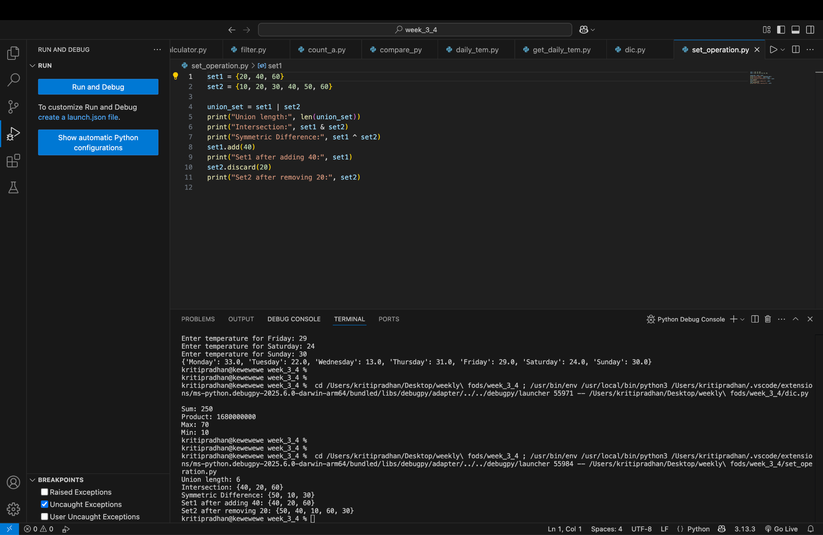
Program 13: Word Intersection
